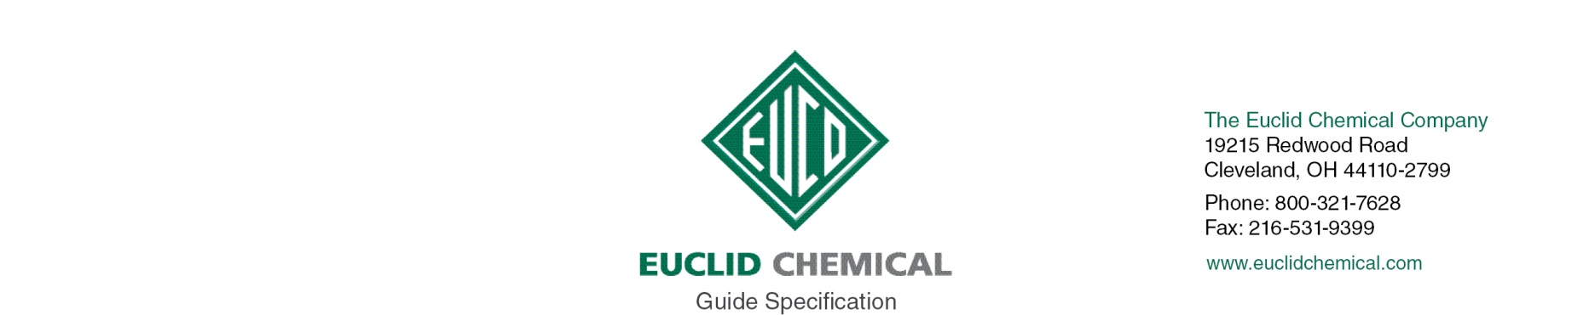
Flex-Con
Acrylic Latex Bonding Agent

FLEX-CON is a water dispersion of architectural grade acrylic latex specifically designed for modifying portland cement compositions.

{Note to Specifier: The paragraphs below are meant to be incorporated into Parts 2 and 3 of a standard CSI 3 Part Format specification, project’s General Structural Notes or directly onto the plans. They must be carefully reviewed by a qualified design professional and edited to meet the particular requirements of the project at hand, assure compliance with any governing building codes, and coordinate with other specification sections and drawings.}

PART 2: PRODUCT

2.__ BONDING AGENT

A. A non-re-emulsifiable, acrylic bonding admixture used to produce polymer modified concrete and mortar. Product shall conform to:
ASTM C 1059 Type II
1. Product:
- Euclid Chemical Company (The); Flex-Con Acrylic Latex Bonding Agent
- www.euclidchemical.com

2.__ Manufacturer shall have ISO 9001 Quality Certification. To ensure compatibility all products shall be from the same manufacturer.

PART 3: EXECUTION

{Note to specifier: For bonding traffic bearing toppings with this product, The Euclid Chemical Company strongly recommends using a bond coat rather than using this product as a primer by itself. Acrylic bonding agents should always be mixed with portland cement and mixed as a slurry; they should not be used neat.}

3.__ EXAMINATION

A. Examine concrete surfaces to receive acrylic bonding agent slurry. Notify Engineer if surfaces are not acceptable. Do not begin surface preparation or application until unacceptable conditions are corrected.

3.__ SURFACE PREPARATION

A. Concrete Removal: Remove all loose and unsound concrete per ICRI Guideline 310.1R “Guide for Surface Preparation”.
1. Unsound concrete surface areas shall have the perimeter boundaries saw cut to a minimum depth of 1/2 inch or less if such depth will cause saw to come in contact with embedded reinforcing steel. All saw cuts shall be made perpendicular to the concrete surface and all concrete removal boundaries shall be straight and aligned parallel to opposite boundary edges resulting in repair areas that are rectangular in shape.
2. All concrete shall be removed from within the repair boundary to minimum depth of 1/2 inch. Provide a surface with suitable profile for bond as defined in repair mortar manufacturer’s written recommendations. If delaminations, cracking, or unsound materials exist beyond the minimum removal depth, then removal shall continue until all unsound, delaminated, and cracked concrete has been removed from the cavity.
3. Provide concrete surface profile CSP stated on manufacturer’s literature per ICRI Guideline 310.2R “Selecting and Specifying Concrete Surface Preparation for Sealers, Coatings, and Polymer Overlays”.

B. Preparing Reinforcing Steel: Clean and prepare embedded reinforcing steel per ICRI Guideline 310.1R.
1. Where 1/2 or more of the diameter of the reinforcement steel is exposed either by existing conditions or concrete removal, the bond between the concrete and the reinforcing steel is broken, or corrosion is present the concrete shall be removed to provide a minimum 3/4 inch clearance around the entire perimeter of the steel and along the entire exposed length.
2. Clean all exposed reinforcing steel to bright steel, prior to installation of repair mortar.
- If section loss of a reinforcing bar is more than 25% or 20% in two or more adjacent bars contact Engineer.

C. Concrete Preparation and Cleaning: Areas to receive concrete repair shall be structurally sound and free from deteriorated concrete, dust, dirt, paint, oil, efflorescence, laitance, and other contaminants, and shall have a Concrete Surface Profile (CSP) equal to that recommended by the repair mortar manufacturer per ICRI Guideline 310.2R. Clean surface using un-oiled compressed air or vacuum clean.

D. For bonding toppings, use a cement bond coat rather than using this product as a primer by itself. After the surface has been prepared, prime all areas with a bond coat before the topping is applied. Follow mixing and placing instructions in accordance with the manufacturer’s written instructions. Place the topping on the bond coat before the bond coat dries out.

3.__ APPLICATION

A. Place acrylic latex bonding agent slurry in accordance with manufacturer’s written instructions.

B. Before slurry coat dries, follow immediately with patching materials that are compatible with portland cement.

